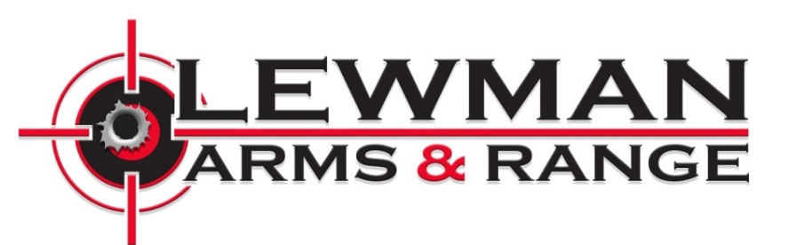

I agree to follow the range/activity safety rules outlined by Lewman Arms:

● I am not under the influence of drugs or alcohol.
● I have not been denied the purchase of a firearm through lawful means.
● I am lawfully permitted to possess and handle a firearm.
● I have not been convicted of a felony or of domestic violence.
● I am not depressed or having suicidal or homicidal thoughts, nor have I made plans to carry out an act of suicide or homicide.
● I understand that if I have rented a firearm, it is not permitted to leave the property or be used in a manner other than what was specified at the time of rental.
● I will seek instruction from a Range Safety Officer prior to handling any firearm I am not familiar with.
● If I do not understand a range rule or procedure or feel there is a safety risk to myself or others, I will notify a Range Safety Officer immediately.
● I understand that I am responsible for any damage to myself, property, or persons by my use or misuse of firearms or actions while on site.
● If a lane is shot down, your time is over. If you wish to move to another lane, there will be an additional $20 fee for the remainder of your hour.

Printed Name____________________________________________
Signature________________________________________________
Date _______/_______/________
Signature of Parent or Guardian if a Minor ____________________________________________________________

